Lab 06: Multiple Regression.

Question 1. Controlling for Other Variables
Using the diagram below, answer the following Questions:
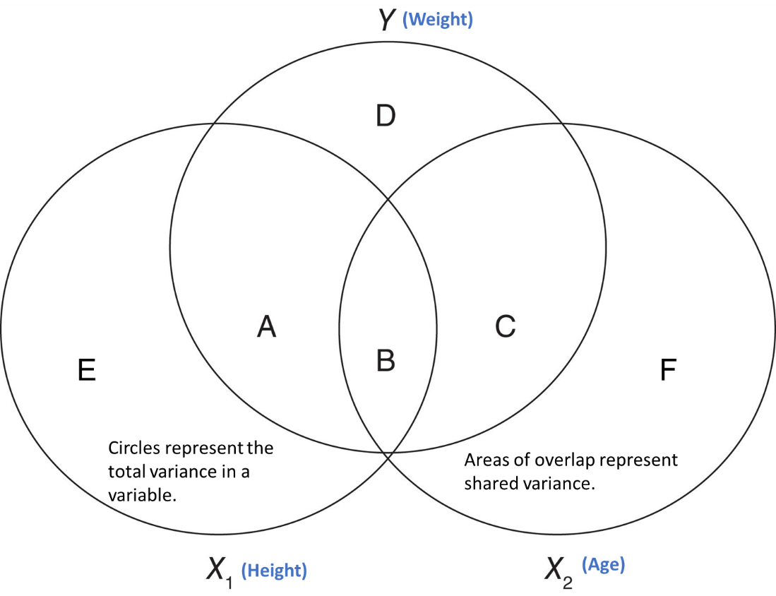
- The sum of which areas represent the total variance in WEIGHT that could be explained by our regression model?

- If we don’t control for AGE, which areas represent the variance in WEIGHT that is shared by HEIGHT?

- If we don’t control for HEIGHT, which areas represent the variance in WEIGHT that is shared by AGE?

- If we don’t control for AGE, the ratio of which areas would show the proportion of WEIGHT that is explained by HEIGHT?
- (A+B)/(A+B+C+D)

- After controlling for AGE, the ratio of what two areas would show the proportion of WEIGHT that is that is explained BY HEIGHT?
- (A)/(A+D)

Question 2. Calculating Slopes and Intercepts
In our multivariable model, we estimate a MODEL A with 3 estimated parameters:
MODEL A ${WEIGHT}_{i}=β_{0}+β_{1}\left({HEIGHT}_{i}\right)+β_{2}\left({AGE}_{i}\right)+ϵ_{i}$
Using R, we “fit” this model to our data. That is, we get estimates for each beta that, when used together, produce the smallest sum of squared errors in our sample.
MODEL A ${WEIGHT}_{i}=-141.22+3.60\left({HEIGHT}_{i}\right)+1.28\left({AGE}_{i}\right)+ϵ_{i}$

Using these values, calculated the estimated WEIGHT for children with the following attributes:
- A child with HEIGHT = 0 and AGE = 0:

- A child with HEIGHT = 58 and AGE = 10:

- A child with HEIGHT = 55 and AGE = 10:

- A child with HEIGHT = 69 and AGE = 14:

- A child with HEIGHT = 69 and AGE = 12:

Question 3. Interpretation
Finally, when we run the model, we get the following statistical output:
Coefficients:
Estimate Std. Error t value Pr(>|t|)
(Intercept) -141.2238 33.3831 -4.230 0.000637 ***
Height 3.5970 0.9055 3.973 0.001093 **
Age 1.2784 3.1101 0.411 0.686492
---
Signif. codes: 0 ‘***’ 0.001 ‘**’ 0.01 ‘*’ 0.05 ‘.’ 0.1 ‘ ’ 1

Residual standard error: 11.51 on 16 degrees of freedom
Multiple R-squared: 0.7729, Adjusted R-squared: 0.7445
F-statistic: 27.23 on 2 and 16 DF, p-value: 7.074e-06

- How should we interpret the slope for the effect of Height?

- How should we interpret the p-value for the effect of Height?

- How should we interpret the effect of Age?

- How should we interpret the p-value for the effect of Age?

- Although it is not labelled as “PRE”, the proportional reduction in error for this model is given by the “Multiple R-squared” in the R output. In this case, we explained about 77.3% of the total error in weight. What Model A and Model C are being compared to generate this figure:
  - Model A: $Type equation here.$

  - Model C: $Type equation here.$

- Similarly, the F(2,16) = 27.23, p < 0.0001 applies to a comparison of the “full” Model A to the “null” Model C. In contrast, the p-values for the effect of Height and the effect of Age come from comparing the full Model A to two different Model C’s.
  - What is the Model C for the effect of Height? $Type equation here.$
  - What is the Model C for the effect of Age? $Type equation here.$

